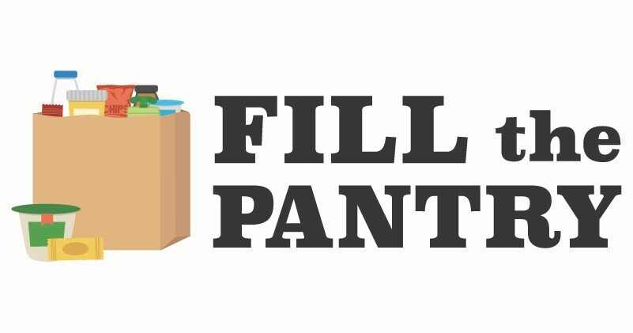
SATURDAY, SEPTEMBER 16th
9:00AM TO 1:00PM

HOST - MIFFLIN AVENUE UM CHURCH
905 MIFFLIN AVENUE

NON-PERISHABLE FOOD, PAPER & CLEANING PRODUCTS, AND TOILETRIES
BENEFITS WILKINSBURG COMMUNITY MINISTRY
WCM is not permitted to distribute expired food due to regulations of the Allegheny County Health Department and PA Dept. of Agriculture.
Please check expiration dates before donating. There may be other organizations that will accept expired food items.

Bring your donations to the glass door entrance on Mifflin Ave. If you would like to make a monetary donation to WCM, make your check payable to WCM and bring to church on Saturday or mail it to
Wilkinsburg Community Ministry, 704 Wood Street, Pgh., PA 15221.

If you are unable to participate on Sept. 16th, bring your donations to the church (glass door entrance) on Sunday mornings between 9:30am and 12:30pm or during office days/hours, Tuesday/Wednesday/Thursday between 9am and 1pm.
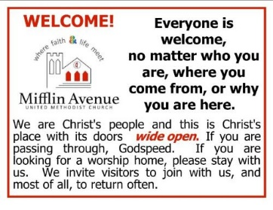
Adult Sunday School 9:45AM
Sunday Service 11:15AM, Zoom Service login contact church office.
Pastor Russel W. Shuluga
Church office (412) 731-2511 - email: office@mifflinave.org
www.mifflinave.org
MARK YOUR CALENDARS:
CANNED SOUP DRIVE WILL BE HELD IN JANUARY 2024
AND NEXT FILL THE PANTRY DRIVE WILL BE HELD IN
JUNE 2024

